Lecture 28: Chapter 12: Files
Announcements

Today’s Goals
- The File Class
- File Input and Output

The File Class

Why Files
- Data stored in variables is temporary – goes away when program ends
- Files give a way to preserve values after program exists

Purpose
- The File Class provides an abstraction
  - Deals with most of machine-dependent complexities of files and path names
  - Wrapper for the filename and its directory path

What it Is Not
- Does not contain the methods to
  - Create a file
  - Read data from a file
  - Write data to a file
- To perform I/O, we need to create objects using appropriate Java I/O classes (next section)

What it is
- Contains the methods for
  - Obtaining file and directory properties
  - Renaming and deleting files and directories
- File name is a string
- List of methods on File class:

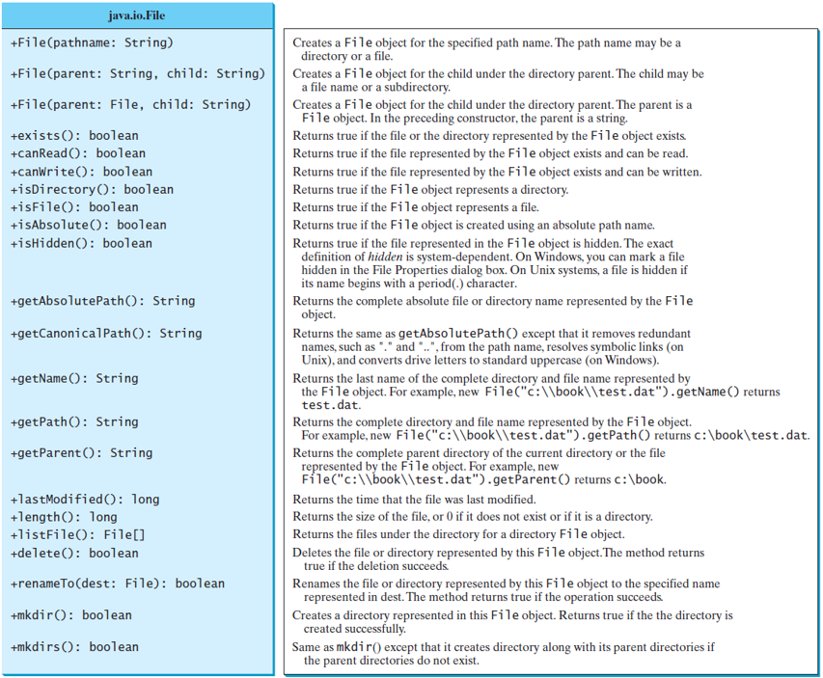

Notes:
- Absolute file name
  - Machine dependent
  - This is the full name
  - Contains the filename with its complete path and drive letter
  - On windows you might have something like:
    - C:\dev\testFile.java
  - On Unix you might have something like:
    - /home/dev/testFile.java

- Relative file name
  - Machine independent
  - File name is in relation to the current working directory
  - Complete directory path is left off
  - testFile.java is a relative file name

- Do not use absolute file names in your program since they will not work on other platforms
- Use file names relative to current directory
Example:
- I created a file named testFile.txt in the directory where my java project was located

// Create a reference variable for the file object
File file = new File("TestFile.txt");

System.out.println("Does it exist? " + file.exists());
System.out.println("File have " + file.length() + " bytes");
System.out.println("Can it be read? " + file.canRead());
System.out.println("Can it be written? " + file.canWrite());
System.out.println("Is it a directory? " + file.isDirectory());
System.out.println("Is it a file? " + file.isFile());
System.out.println("Absolute path is " + file.getAbsolutePath());

Displays
Does it exist? true
File have 0 bytes
Can it be read? true
Can it be written? true
Is it a directory? false
Is it a file? true
Absolute path is C:\Dev\eclipse_workspace\CS1150\testFile.txt

File Input and Output

Performing I/O
- Need to create objects using appropriate Java I/O classes
- These objects contain the methods for reading/writing data to/from a file
- PrintWriter
  - Use to write data to a file
- Scanner
  - Use to read data from a file

Writing File Data
- PrintWriter class is used to:
  - Create a file
  - Write data to a file

- Creating a PrintWriter object
  - Main needs to throw exception when using PrintWriter – otherwise compiler error!
  - Create a PrintWriter object
  - Write data to the file using print, println, and printf methods on PrintWriter

public static void main(String[] args) throws IOException {

// Setup a file reference variable The PrintWriter
File outputFileName = new File("OutputFile.txt"); constructor may
throw exception
// Create a new file
PrintWriter resultsFile = new PrintWriter (outputFileName);
resultsFile.println("This text will now be written to the file");
resultsFile.println("This text is also written to the file");
resultsFile.close();
}
- Print methods are overloaded
- We can write strings, characters, integers, etc. to files!

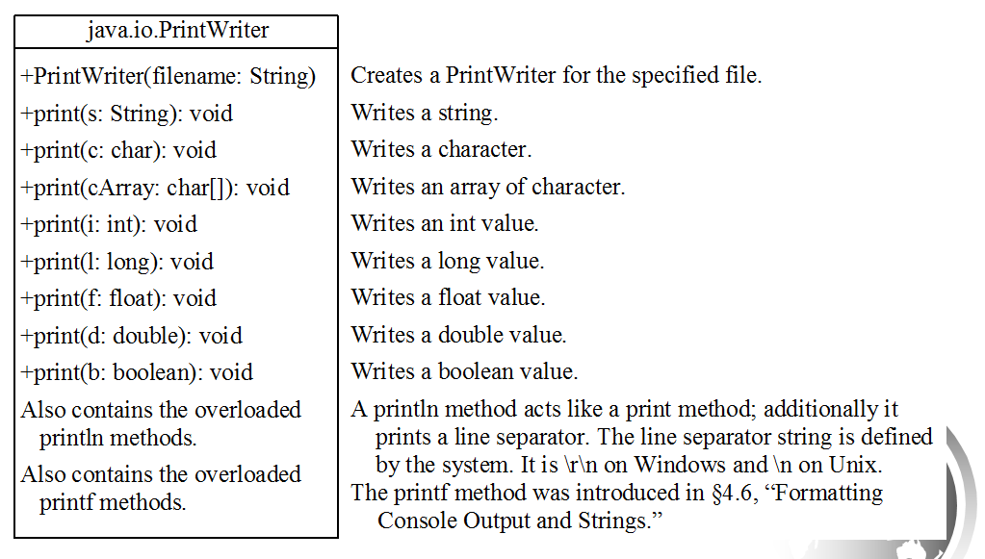

Reading File Data
- Scanner class is used to
  - Read text data from a file

- Creating a Scanner object
  - We’ve used the Scanner class to create objects to read data from keyboard

Scanner input = new Scanner(System.in);

System.out.print("Enter an index: ");
int index = input.nextInt();

  - Scanner can also be used to read data from a file

File inputFileName = new File("TestFile.txt");

// Create a scanner for the file
Scanner inputFile = new Scanner (inputFileName);

System.out.println("Value read from TestFile.txt is " + inputFile.nextInt());
inputFile.close();

Displays
The value read from TestFile.txt is 100

Example
- Place this code in a file and run it.
- Read the comments to get an understanding of the different steps required when dealing with files.

// When writing to and reading from files you need to import several classes.
// You need: File, IOException, PrintWriter and Scanner
import java.io.File;
import java.io.IOException;
import java.io.PrintWriter;
import java.util.Scanner;

public class FileExample {
public static void main(String[] args) throws IOException {

// First note that when working with files main needs to throw an exception.
// Now let's start with writing to a file.
// This is a good exercise since it shows you where Eclipse looks for files.

// First setup a file reference variable to refer to the text file.
// Note that the file has NOT been created on your hard drive yet,
// this only creates the reference variable.
// The variable fileName is how to refer to the file OutputFile.txt on the hard drive.
File fileName = new File("OutputFile.txt");

// Second create the file.
// The PrintWriter class is used to write data to a file.
// I will now use the variable resultsFile any time I need to write to OutputFile.txt
// If you look on your hard drive you will now see the file OutputFile.txt
// The file will be in your eclipse workspace in the CS1150 folder (or whatever you
// named your project for this class in Eclipse).
PrintWriter resultsFile = new PrintWriter (fileName);

// Third write something to the file.
resultsFile.println("This text will now be written to a file");
resultsFile.println("This text is also written to the file");

// Fourth close the file.
// To prove writing to the file worked properly, open the file and verify it contains
// the above two lines.
resultsFile.close();

// The next step is to read from a file.
// Reading from a file is very similar to reading from the keyboard.
// First open the file for reading by creating a scanner for the file.
// Note: I'm using the same variable - fileName - so I'm opening the file OutputFile.txt
// on my hard drive, this time for reading.
Scanner inputFile = new Scanner (fileName);

// Second prove that I actually read something from the file.
// Note the use of the method nextLine. The point is to use the methods in Scanner class
// to obtain the information from the file. With numbers, use nextInt, nextDouble, etc.
// There is no need to read a line of numbers and then parse the line to get the values.
// Let the Scanner methods do the work!
System.out.println("Value read from OutputFile.txt is: " + inputFile.nextLine());

// Third close the file.
inputFile.close();

} // main
} //FileExample

- Output
  - Value read from OutputFile.txt is: This text will now be written to a file

